Name: Class:

Task 1
The table below contains a set of addresses. Tick all the addresses that are valid MAC addresses. For those that are not valid, explain why they aren’t.
Address | Tick if a valid MAC address | If not a valid MAC address explain why
5d-cd-94-2a-99-0a
4e-f6-93-5d-bc-2a-3d
78-3e-bc-g7-93-22
ac-dc-bc-cc-be-ad
bb-2a-cd-83-21
32-59-40-00-28-32

Task 2
Look at the following MAC address:
57:9a:29:2f:3d:a0
Convert the MAC address into binary.

Task 3
(a) Two stickers from network routers are shown below. For each one, identify the MAC address and manufacturer code.
Sticker 1:
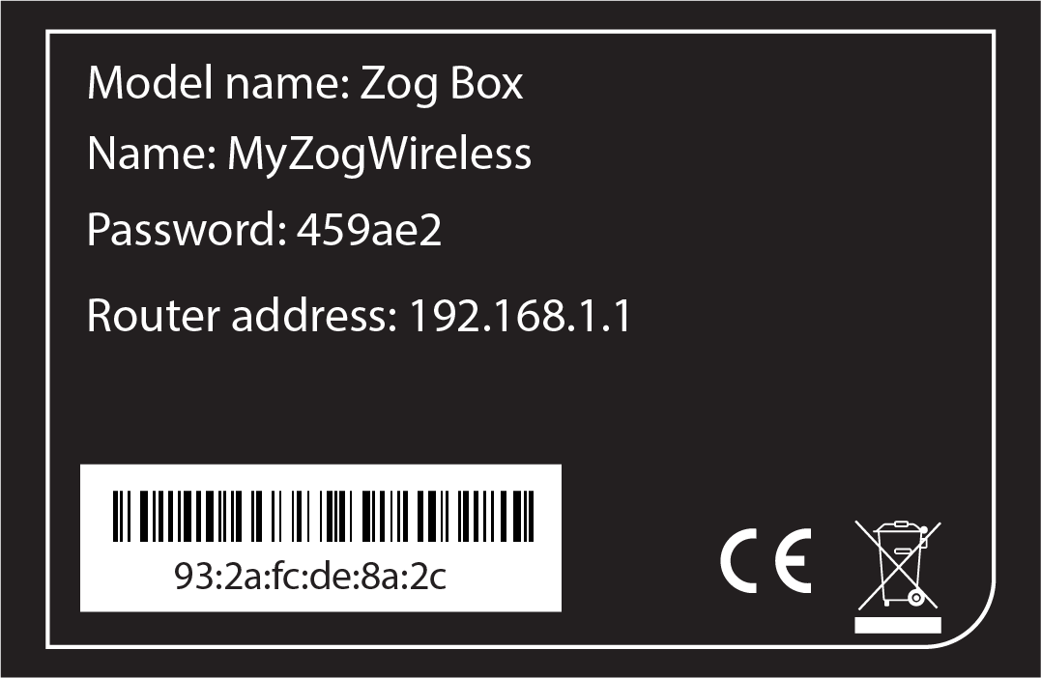 | MAC address:
 | Manufacturer code:
Sticker 2:
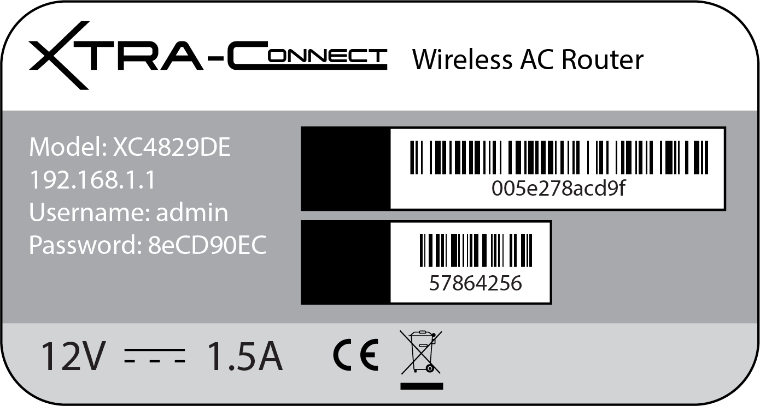 | MAC address:
 | Manufacturer code:

(b) Perform an image search in a web browser for:
‘Router sticker’
Select three stickers that contain their MAC address and copy them into the table below.
For each sticker, determine the manufacturer that is registered to the MAC address. If the name of the manufacturer is on the sticker, use this to confirm you have correctly identified it.
Sites that will help you to identify the manufacturer include:
https://macvendors.com/
https://macaddress.io/mac-address-lookup/mw56npE95o
Sticker | MAC address manufacturer
(c) Find the MAC address of other devices such as smartphone, tablet or computer.
You may have more than one MAC address for the same device as there will be a MAC address for Ethernet, Wi-Fi and Bluetooth.
Complete the table below with the MAC addresses that you have found, then look up the manufacturer to see that it corresponds with the manufacturer you would expect.
MAC address | MAC address manufacturer

